

ADEENA YASIN 08-FMS/BSBA/F21

Program: BSBA – Business Analytics
Department: Management Sciences

PROJECT TITLE:
Balanced Scorecard Analysis of Jazz Telecom Company Using Power BI
Partner Industry:
Jazz (Pakistan Mobile Communications Limited)
SUBMITTED TO: MA’AM SAMINA ALI ASGHAR
SUBMISSION DATE: 26-MAY -2025

Balanced Scorecard Analysis of Jazz Telecom Company Using Power BI
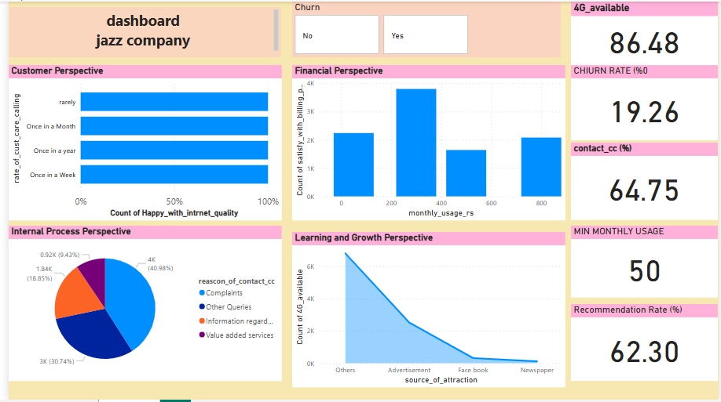

Acknowledgments
We would like to express our sincere gratitude to Jazz Telecom for their invaluable support and for providing us with access to essential insights and data required for this project.
We are also thankful to our university and the Department of Business Administration for giving us this opportunity to work on a real-world problem and apply our academic learning to industry challenges.
Special thanks to our university supervisor, [ma’am Samina Ali], , whose guidance, mentorship, and feedback played a crucial role in the successful completion of this project.
We would also like to acknowledge the collective efforts of our team. The collaboration, dedication, and consistent efforts of each team member made this project a success.
Executive Summary
This report presents a comprehensive industrial project aimed at implementing the Balanced Scorecard (BSC) framework through Power BI for Jazz Telecom Pakistan. The project’s core objective was to measure and enhance organizational performance by analyzing data from a customer survey and integrating it into the BSC model, thereby enabling strategic decision-making through visual dashboards.
The Balanced Scorecard was constructed based on four key perspectives: Financial, Customer, Internal Business Processes, and Learning & Growth. Data was collected using structured questionnaires distributed among Jazz users, and responses were analyzed to derive meaningful KPIs (Key Performance Indicators).
Using Power BI, we developed interactive dashboards to visualize trends, identify performance gaps, and propose actionable recommendations. Key insights included a moderate churn rate, high customer dissatisfaction in internet quality, and potential areas for marketing improvement.
Our findings highlight critical challenges and opportunities within Jazz’s operational ecosystem. Recommendations were proposed to reduce churn, enhance customer engagement, and improve internal processes. The strategic alignment of these actions is expected to bolster Jazz’s long-term performance and competitiveness.

4. Table of Contents
- Title Page
- Acknowledgments
- Executive Summary
- Table of Contents
- Introduction
- Company Profile
- Literature Review / Theoretical Background
- Methodology
- Balanced Scorecard Development
- Data Analysis & Visualization (Power BI)
- Gap Analysis
- Strategic Recommendations
- Integration with Organizational Strategy
- Implementation Plan
- Challenges & Limitations
- Conclusion
- References
- Appendices

5. Introduction
In today’s highly competitive business environment, performance management has become a cornerstone for achieving strategic success. Organizations are constantly striving to enhance their performance by aligning their activities with strategic objectives, monitoring real-time metrics, and utilizing data-driven decision-making tools.
The Balanced Scorecard (BSC), developed by Kaplan and Norton, has emerged as a widely adopted performance management tool that helps organizations translate their vision and strategy into a coherent set of performance measures across four critical perspectives: Financial, Customer, Internal Business Processes, and Learning & Growth.
The purpose of our project is to design and implement a performance management system using the BSC framework integrated with Power BI for Jazz Telecom. By transforming raw data into meaningful insights through visualization, we aimed to support Jazz in making informed decisions that align with their strategic goals.
We selected Power BI due to its powerful data integration, transformation, and visualization capabilities. The use of questionnaires to gather primary data from customers allowed us to customize the BSC to reflect Jazz’s real-world business context and challenges. This project not only serves as an academic endeavor but also as a practical solution for enhancing business performance through analytics.

Company Profile: Jazz
Background:
Jazz is a major telecom provider in Pakistan formed by the merger of Mobilink and Warid in 2016.
Vision:
"To empower every Pakistani with seamless connectivity and digital solutions."
Mission:
Deliver innovative and reliable services to create a digital Pakistan.
Core Values:
- Customer Centricity
- Innovation
- Agility
- Trust
Services:
Voice, SMS, 4G Internet, Digital Financial Services (JazzCash), and Business Solutions.
Organizational Structure:
Hierarchical with centralized decision-making, supported by marketing, IT, HR, and finance departments.
Strategic Goals:
- Improve customer satisfaction
- Expand 4G coverage
- Reduce churn rate
- Drive digital innovation

Literature Review / Theoretical Background

Balanced Scorecard (Kaplan & Norton)
A strategy performance tool measuring success across four perspectives.

KPIs (Key Performance Indicators)
Quantifiable metrics used to evaluate success (e.g., churn rate, complaint ratio, 4G availability).

Strategic Alignment
BSC aligns business activities with strategic goals through clear performance measures.

Role of Visualization Tools
Power BI enables organizations to monitor KPIs in real time, fostering informed decision-making.

Methodology

Research Design
Quantitative – Survey-based approach using structured questionnaires.

Data Collection Methods
- Questionnaire (Google Form) — filled by Jazz users
- No interviews or internal reports used

Tools Used
- Power BI (dashboarding)
- Excel (data cleaning)
- Google Forms (survey)

Ethical Considerations
- Voluntary participation
- Anonymity and confidentiality maintained
- Data used only for academic purposes

Balanced Scorecard Development

a. Strategic Mapping
Customer Perspective:
- Reduce churn
- Increase recommendation rate
Financial Perspective:
- Maximize revenue per user
- Optimize cost-efficiency
Internal Processes:
- Improve complaint resolution
- Enhance service availability
Learning & Growth:
- Increase 4G awareness
- Strengthen digital marketing impact

b. KPIs
Perspective | KPI | Source
Customer | Churn Rate, Recommendation Rate | Survey
Financial | Monthly Usage, Billing Satisfaction | Survey
Internal Processes | Complaint Ratio, CC Contact Satisfaction | Survey
Learning & Growth | 4G Availability, Source of Awareness | Survey

c. Performance Targets
Benchmarks were estimated based on market research and best practices (e.g., churn < 10%).

. Data Analysis & Visualization (Power BI)
- Data imported and cleaned in Excel
- Dashboards built in Power BI

Key Visuals:
- Bar Chart: Monthly Usage & Satisfaction
- Pie Chart: Reason for Contacting CC
- Line Graph: Source of Awareness
- Scorecards: Churn Rate, 4G Availability, Contact Center Score, Recommendation Rate
- Bar Chart: Internet Quality vs. Call Frequency
(Screenshot of dashboard attached in Appendix)

Gap Analysis
KPI | Target | Actual | Gap
Churn Rate | <10% | 19.26% | High churn
Contact Center Satisfaction | >80% | 64.75% | Below target
Recommendation Rate | >70% | 62.30% | Improvement needed

Strategic Recommendations
- Loyalty Programs to retain customers
- AI Chatbots for faster CC response
- 4G Campaigns targeting digital users
- Survey-based Feedback System
- Customer Segmentation to offer personalized plans

Integration with Organizational Strategy
The BSC helps Jazz align its operational metrics with its mission to become Pakistan’s leading digital enabler. The dashboard ensures leadership stays focused on key performance areas while driving company-wide accountability.

Implementation Plan
Phase | Timeline | Activities
Phase 1 | Week 1–2 | Data Collection via Questionnaire
Phase 2 | Week 3 | Data Cleaning & Preprocessing
Phase 3 | Week 4 | Power BI Dashboard Development
Phase 4 | Week 5 | Report Writing & Final Review

Challenges & Limitations
- Limited sample size due to time constraints
- Bias in survey responses
- Lack of internal company data
- No direct interviews with managers
- Dependence on self-reported figures

Conclusion
This project demonstrated how the Balanced Scorecard, supported by Power BI, can be used to evaluate and improve company performance. While Jazz has high 4G availability and user engagement, issues like churn and CC efficiency must be addressed to maintain a competitive edge. The BSC ensures holistic performance management and supports Jazz’s vision for digital excellence.

References
- Kaplan, R. S., & Norton, D. P. (1992). The Balanced Scorecard: Measures That Drive Performance. Harvard Business Review.
- Parmenter, D. (2015). Key Performance Indicators: Developing, Implementing, and Using Winning KPIs.
- Power BI Documentation: https://learn.microsoft.com/en-us/power-bi/
- Telecom Industry Reports (2024)

Appendices
- A. Survey Questionnaire
- B. Dashboard Screenshots
- C. Raw Data in Excel Format
- D. Glossary of Key Terms
- E. Strategy Map (from Lucidchart)

